ACHIEVEMENTS FROM 2018-2023

1. In addition to the regular courses, our department offers Certificate and value added Courses. Students are encouraged to give presentation so that they will learn the subjects thoroughly in addition to improving their communication and presentation skills.

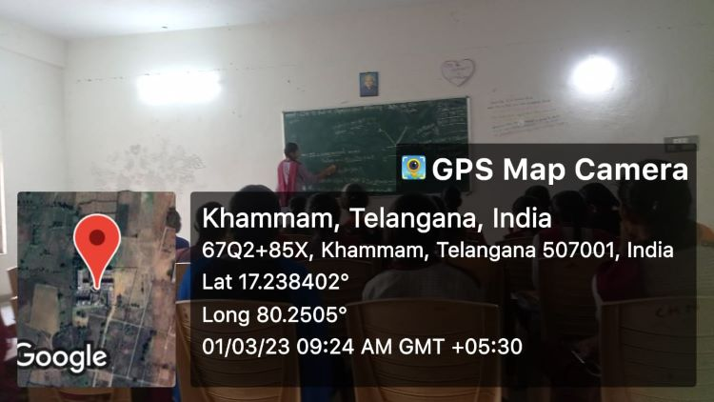

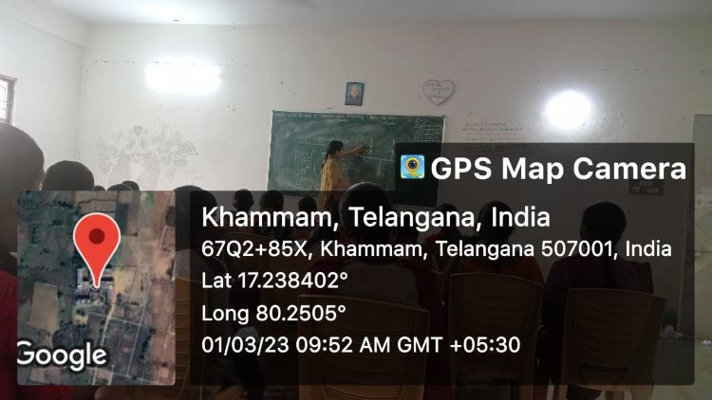

**Coaching for CPGET and IIT - JAM.**

**P.G STUDENT LISTS:**

**Department of Physics started free coaching started coaching from 2020-21,. Classes we conducted The following students attended for PG Coaching and got admitted into Various Institutions.**

|  |  |  |  |  |  |  |
| --- | --- | --- | --- | --- | --- | --- |
| Sl.No | HT.No | NAME OF THE STUDENT | GROUP | Rank in CPGET | YEAR | Admitted Institution(M.Sc Physics) |
| 1 | 69024290018 | V.Laxmi Prabha | lll MPCS | 22 | 2021 | OU Campus, Hyderabad. |
| 2 | 69024290017 | Ch.Srinavya | III MPCS | 246 | 2021 | OU Campus, Hyderabad. |
| 3 | 69024290069 | A.Mamatha Sri | III MPCS | 283 | 2021 | OU Campus, Hyderabad |
| 4 | 69093770491 | T.Mankisha | III MPCS | 507 | 2021 | KU Campus,Warangal |
| 5 | 69033350018 | M.Sandhya | III MPCs | 118 | 2022 | Nizam College Campus, Hyderabad. |
| 6 | 69033350019 | DS.Anitha | III MPC | 243 | 2022 | OU Campus, Hyderabad |
| 7 | 69033350006 | A.Pravalika | III MPCS | 329 | 2022 | KU Campus,Warangal |
| 8 | 69033350115 | M.Ramya | III MPCS | 500 | 2022 | MG University, Nalgonda. |
| 9 | 69033350015 | S.Soniya | III MPC | 715 | 2022 | TG University Campus, Nizamabad |
| 10 | 69033350044 | K.Padmavathi | III MPC | 912 | 2022 | Admitted in B.Ed |
| 11 | 69033350032 | M.Dhanalaxmi | III MPC | 1072 | 2022 | Admitted in B.Ed |
| 12 | 69033350022 | V.Ramadevi | III MPCS | 1235 | 2022 | PG Centre,Siddipet. |
| 13 | 69033350191 | D.Srilekha | III MPC | 1607 | 2022 | Admitted in B.Ed |
| 14 | 69080280513 | K.Krishnaveni | III MPC | 383 | 2023 | KOTI Womens’ College Campus, Hyderabad. |
| 15 | 69024050023 | K.Sravani | III MPCS | 1094 | 2023 | UPGC, Palamur University, Mahabubnagar. |

|  |  |  |
| --- | --- | --- |
| SLNO | YEAR | NUMBER OF STUDENTS JOINED FOR HIGHER EDUCATION |
| 1 | 2018-21 | 4 |
| 2 | 2019-22 | 10 |
| 3 | 2020-23 | 4 |
|  |  |  |